MONTHLY TEST- JUNE - 2019
Marks obtained:

Total:
25
Name: _____________
Grade: II Section___
Subject: Maths
Date: 24.6.19
Time: 1 Hour

I. Draw lines to match solid shape to the correct shape. (5x1=5)
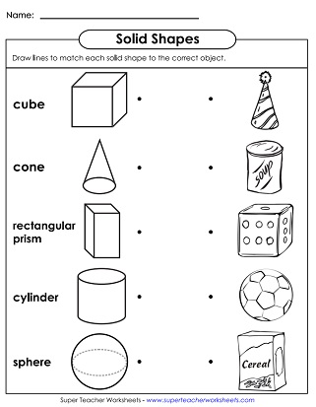

II. Complete the missing numbers. (4x1=4)
a) 12, _____, _____, ______, _____
b) 33, _____, _____, ______, _____
c) 6, _____, ______, _____, _____
d) _____, 44, ______, ______, ____

III. Read the statements and choose the correct option. (4x1=4)
- I have three sides and three corners
I am a square/triangle
- I have four sides and four corners. All my sides are equal.
I am a square/ rectangle
- I have no straight sides and no corners
I am a rectangle/ circle
- I have four sides and four corners. Two of my sides are long and equal and two are short and equal.

I am a square/ rectangle

IV. Look at the picture and follow the given instructions. (5x1=5)

- Draw flowers on the corners of triangle
- Color the circle with red
- Draw square on corners of the rectangle
- How many shapes are there in the picture?______________
- Which is your favourite shape.________________________?
V. Use a ruler and draw a straight line. (1x2=2)

VI. Circle the biggest number. (4x1=4)
a) 19 29
b) 33 50
c) 7 5
d) 10 20
******************************************************************************************

